GLOW LOGICS DIGITAL MARKETING
A PROJECT ON
SOCIAL MEDIA MARKETING STRATEGY FOR A FASHION BRAND
Bachelor of Science in AI&DS
Ⅱ YEAR B.Sc – (AI&DS)
Submitted by,
S.ARAVINDH (Reg.No:12225050010)
DEPARTMENT OF SCIENCE

DHANALAKSHMI SRINIVASAN UNIVERSITY SCHOOL OF ARTS & SCIENCE
SAMAYAPURAM,TRICHY- 621112.

SEPTEMBER- 2026

TABLE OF CONTENTS
Project structure

No. | Section | Page
1 | Introduction | 1
2 | About the selected  fashion brand | 2
3 | Vision, mission and  objectives | 3
4 | Market and industry  overview | 4
5 | Situation Analysis | 5
6 | SWOT Analysis  Diagram | 6
7 | Competitor analysis  framework | 7
8 | Target Audience | 8
9 | Buyer Personas | 9
10 | Brand Positioning | 10
11 | Social Media Goals | 11
12 | Platform Strategy | 12
13 | Instagram Strategy | 13

14 | TikTok Strategy | 14
15 | YouTube and  Pinterest Strategy | 15
16 | Content Marketing  Strategy | 16
17 | Content Pillars | 17
18 | Visual Identity Strategy | 18
19 | Social Media  Copywriting | 19
20 | Influencer Marketing Strategy | 20
21 | Influencer Campaign  Plan | 21
22 | User-Generated  Content Strategy | 22
23 | Paid Social Media Advertising | 23
24 | Social Commerce  Strategy | 24
25 | Customer Journey Mapping | 25
26 | Engagement Strategy | 26
27 | Social Media Campaign Ideas | 27
28 | Content Calendar | 28
29 | 30-Day Content Plan | 29
30 | Social Media  Analytics | 30
31 | KPI Dashboard and  Reporting | 31

32 | A/B Testing Strategy | 32
33 | Social Media Crisis  Management | 33
34 | Social Media  Governance | 34
35 | Budget Allocation  Framework | 35
36 | Implementation  Roadmap | 36
37 | Expected Outcomes | 37
38 | Challenges and  Recommendations | 38
39 | Conclusion | 39

Social Media Marketing Strategy for a Fashion Brand

Flowchart with Sentence Explanation

Introduction

Explains the importance of social media marketing in the fashion industry.

About the Fashion Brand

Introduces the brand, its products, vision, mission and objectives.

Market and Situation Analysis

Studies market trends, competitors, target customers and SWOT factors.

Target Audience and Brand Positioning

Identifies potential customers and establishes a distinctive brand identity.

Social Media Platform Strategy

Selects suitable platforms such as Instagram, TikTok, YouTube and Pinterest.

Content and Influencer Marketing

Plans posts, videos, visual identity, influencer collaborations and customer-created content.

Advertising and Customer Engagement

Uses paid advertisements, social commerce and campaigns to engage customers and encourage purchases.

Content Calendar and Implementation

Schedules content, allocates the budget and implements the marketing plan.

Performance Measurement

Measures reach, engagement, website traffic, conversions and campaign results using KPIs and A/B testing.

Conclusion and Recommendations

Summarizes the strategy and recommends improvements for long-term brand growth.

Introduction

Background

Social media has transformed the way fashion brands communicate with customers. Fashion is highly visual, trend-driven and influenced by communities, creators and peer recommendations. Platforms such as Instagram, TikTok, YouTube, Pinterest and Facebook allow fashion brands to present products, demonstrate styling ideas, tell brand stories and develop long-term relationships with customers.

Meaning of Social Media Marketing
Social media marketing is the planned use of social platforms to communicate with a target audience, create awareness, encourage interaction, generate website traffic and support business objectives. For fashion brands, social media can function as a discovery channel, content platform, customer-service channel and commerce-support channel.

Purpose of the Project
This project develops a complete social media marketing strategy for Lumora Fashion, a fictional contemporary fashion brand. The strategy covers market understanding, audience segmentation, positioning, platform selection, content strategy, influencer marketing, paid advertising, customer journey, campaign planning, measurement, risk management and implementation.

Brand Concept
Lumora Fashion is designed as a contemporary fashion brand offering accessible, stylish and versatile clothing for young adults. The brand concept combines modern silhouettes, everyday comfort and social-first storytelling.

Brand Element | Proposed Direction
Brand name | Lumora Fashion
Category | Contemporary fashion
Target market | Young adults and style-conscious professionals
Positioning | Modern, wearable and digitally engaging fashion
Product focus | Tops, dresses, co-ords, casual wear and accessories
Primary sales channel | Brand website / online store
Primary communication | Social media and creator-led content
Brand personality | Fresh, confident, friendly and creative

Brand Promise
“Make everyday style feel personal.” The promise focuses on helping customers discover outfits that fit their personality, lifestyle and occasions.

Vision
To build a recognizable digital-first fashion community where customers discover, style and share contemporary fashion.

Mission
To deliver accessible fashion supported by useful styling content, authentic community interaction and a seamless digital customer experience.

Marketing Objectives
    - Build brand awareness among the selected target audience.
    - Grow a relevant and engaged social community.
    - Increase qualified visits to the online store.
    - Generate product discovery and purchase intent.
    - Encourage customer-generated content and reviews.
    - Build repeat engagement and customer loyalty.
    - Create measurable social media campaigns.

SMART Objective Framework
Objective | Measure | Time Frame
Awareness | Reach and video views | First 90 days
Engagement | Engagement rate, saves, shares, comments | Monthly
Traffic | Social sessions and product-page visits | Monthly
Conversion | Purchases attributed to social | Monthly
Community | UGC posts and tagged mentions | Quarterly
Retention | Repeat customers and returning social users | Quarterly

Fashion Industry Characteristics

Fashion is influenced by seasonality, cultural trends, celebrity and creator influence, visual aesthetics and changing consumer preferences. Social platforms shorten the distance between trend discovery and purchase consideration.

Social Media Opportunity

    - Visual platforms allow products to be demonstrated in real-life situations.

    - Short-form video can communicate styling ideas quickly.

    - Creators can introduce products through trusted voices.

    - UGC can provide social proof.

    - Interactive features can collect audience preferences.

    - Retargeting can reconnect with users who have already shown interest.

Strategic Challenge

The main challenge is not simply gaining followers. The brand must attract the right audience, maintain a recognizable identity, produce useful content consistently and connect social engagement with meaningful business outcomes.

Strengths
    - Highly visual product category.
    - Large variety of content formats available.
    - Strong potential for creator collaborations.
    - UGC can demonstrate real-world styling.
    - Frequent product launches create content opportunities.

Weaknesses
    - High competition for attention.
    - Fashion trends change rapidly.
    - Content production can become expensive.
    - Audience may be highly price-sensitive.
    - Over-reliance on promotional content can reduce engagement.

Opportunities
    - Creator-led styling videos.
    - Community challenges and UGC.
    - Personalized recommendations.
    - Short-form video series.
    - Social commerce features where available.
    - Localized content and micro-influencer partnerships.

Threats
    - Fast-moving competitors.
    - Algorithm changes.
    - Negative reviews or viral complaints.
    - Trend fatigue.
    - Ad cost increases.

6.1 SWOT Framework

Strengths | Weaknesses
Visual product category | Content production demands
Creator potential | Competitive social environment
UGC opportunities | Potential price sensitivity
Frequent launches | Need for consistent identity
Opportunities | Threats
Creator styling content | Algorithm changes
Community campaigns | Competitor activity
Short-form video | Negative viral feedback
Social commerce | Rising advertising costs

The SWOT analysis suggests that Lumora should build differentiation through consistent visual identity, useful styling content, authentic creators and community participation rather than depending only on discounts.

For academic planning, competitors should be evaluated according to audience, content style, product positioning, engagement approach and promotional activity. The table below is a framework rather than a claim about current performance of any named competitor.

Factor | Brand A | Brand B | Brand C | Lumora Goal
Visual identity | Review | Review | Review | Distinctive and consistent
Content formats | Review | Review | Review | Video + carousel  + UGC
Creator strategy | Review | Review | Review | Micro + mid-tier creators
Community engagement | Review | Review | Review | Active two-way interaction
Offers | Review | Review | Review | Selective, not constant
Customer proof | Review | Review | Review | Reviews + UGC

7.1 Competitive Learning
The purpose of competitor analysis is to identify patterns and gaps. Lumora should document competitor examples, but avoid copying creative concepts. The strategy should translate category learning into a distinctive brand expression.

Primary Segment

Young adults approximately 18–34 who enjoy fashion discovery through social media, follow creators and value outfits that can be styled for multiple occasions.

Secondary Segment
Working professionals and occasion shoppers seeking contemporary outfits that balance trend, comfort and versatility.

Audience Needs

    - Affordable style inspiration.

    - Simple outfit ideas.
    - Confidence in fit and styling.

    - Social proof from real people.

    - Convenient online shopping.
    - Newness and trend discovery.
    - Responsive customer support.

Audience Behaviour Hypotheses
The strategy assumes that the target audience discovers products through short-form video, saves styling ideas, checks creator opinions, compares products and seeks reassurance through reviews before purchasing. These assumptions should be validated using analytics and customer research.

Persona | Profile | Content Need | CTA
Trend Explorer | 18–24, follows creators, enjoys new looks | Reels, trends, creator styling | Shop new drop
Everyday Stylist | 23–30, wants versatile outfits | Carousels, outfit guides | View collection
Professional Shopper | 25–34, values polished looks | Workwear edits, styling tips | Explore edit
Occasion Shopper | 20–35, shops for events | Lookbooks, try-ons, UGC | Shop occasion edit

Persona Development
Personas help convert a broad demographic into practical communication decisions. Each persona should have a clear problem, content need and next action. The brand can use different creative hooks without changing its core identity.

Personalization
Personalization can be achieved through content themes, not necessarily by collecting sensitive personal information. Examples include occasion-based collections, style quizzes, outfit bundles and creator edits.

Positioning Statement

For style-conscious young adults who want contemporary fashion that feels easy to wear, Lumora Fashion provides modern, versatile pieces supported by practical styling inspiration and a welcoming digital community.

Differentiation Pillars

    - Wearability: outfits designed for real-life occasions.
    - Style education: help customers understand how to combine pieces.

    - Community: customers participate in the brand story.

    - Visual consistency: recognizable social identity.
    - Approachable personality: friendly rather than overly formal.

Brand Personality

Trait | Expression
Confident | Clear styling recommendations
Friendly | Conversational captions and replies
Creative | Unexpected styling combinations
Modern | Contemporary visual direction
Inclusive | Varied styling and customer representation

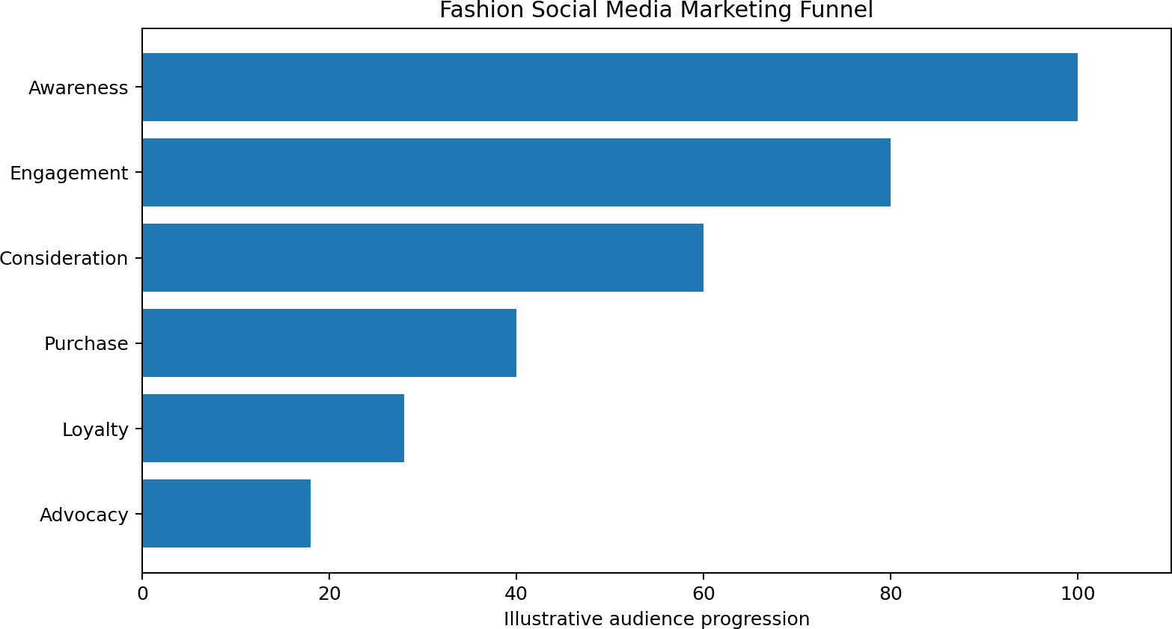

Funnel-Based Goals

Stage | Goal | Content
Awareness | Reach relevant people | Reels, creator videos, trend content
Engagement | Generate interaction | Polls, comments, carousels, Q&A
Consideration | Build product interest | Try-ons, reviews, styling guides
Conversion | Support purchase | Product demos, offers, retargeting
Loyalty | Encourage repeat interaction | UGC, community content, early access
Advocacy | Encourage sharing | Challenges, customer features, referrals

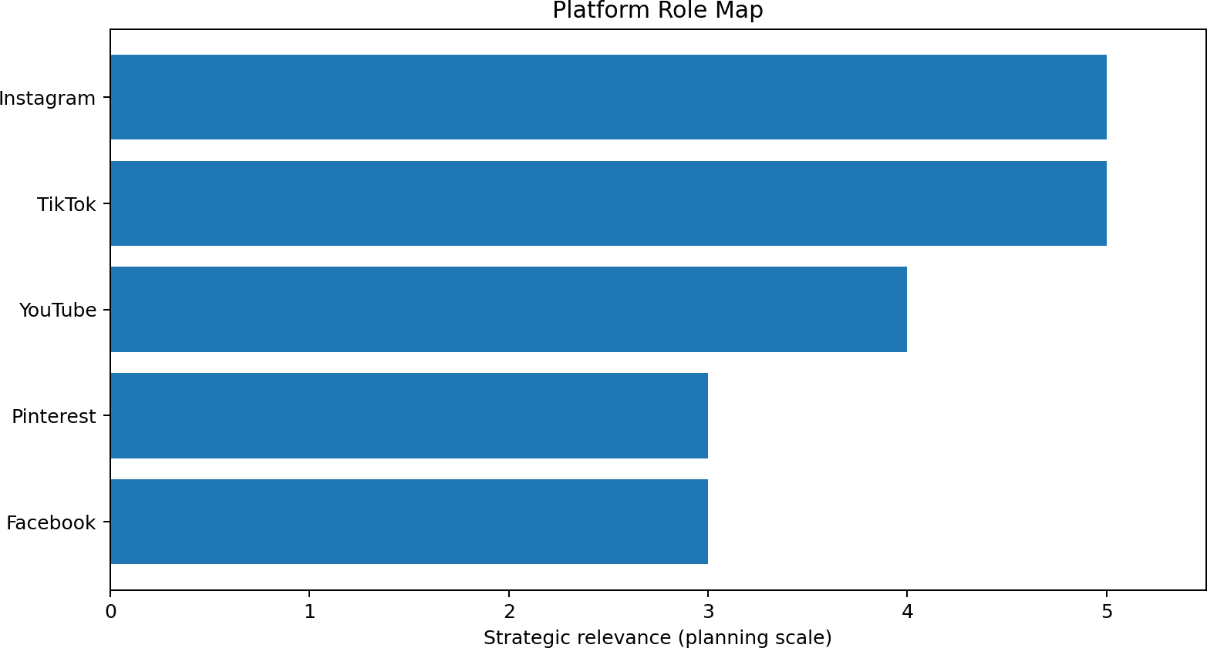

Each platform should have a defined role rather than reposting identical content everywhere.

Platform | Primary Role | Content Style
Instagram | Brand hub | Reels, Stories, carousels, UGC, Lives
TikTok | Discovery | Short videos, styling, trends, creators
YouTube | Depth and search | Hauls, lookbooks, styling tutorials
Pinterest | Inspiration | Boards, outfit ideas, visual search
Facebook | Community and remarketing | Offers, community updates, selected video

Content Mix

    - Short-form styling Reels.

    - Product-detail carousels.

    - Customer UGC.

    - Behind-the-scenes Stories.

    - Creator collaborations.

    - Launch countdowns.

    - Live styling sessions.

Story Strategy

Stories can be used for daily interaction: polls, product questions, outfit choices, countdowns, restock alerts, behind-the-scenes clips and customer reposts.

Instagram Community Management

Comments and direct messages should receive timely, helpful responses. Frequently asked questions can be converted into saved highlights or future content.

Role of TikTok

TikTok can serve as a discovery channel for entertaining, educational and trend-responsive fashion content. The brand should adapt to platform-native storytelling rather than simply reposting polished advertisements.

Video Ideas

    - 3 ways to style one top.
    - One outfit, three occasions.

    - Before-and-after styling.

    - Pack an outfit with me.
    - Customer style challenge.

    - Creator try-on.
    - Fashion myths and tips.
    - Behind-the-scenes product shoot.

Creative Principle
Start with a strong visual hook, keep the message focused, show the product naturally and end with a relevant action. Trends should be used only when they fit the brand.

YouTube

YouTube can provide deeper content such as seasonal lookbooks, styling tutorials, wardrobe guides, creator collaborations and product explainers. Longer videos can also be repurposed into short clips.

Pinterest

Pinterest can support visual discovery through outfit boards, occasion inspiration, colour combinations and capsule wardrobe ideas. Content should use descriptive titles and links to relevant website pages.

Content Repurposing

Original Asset | Repurposed Assets
10-minute styling video | YouTube Short + Reels + TikTok + quote card
Product photoshoot | Carousel + Story + Pinterest pins
Customer review | Quote graphic + Reel + product-page proof
Creator collaboration | Short clips + Stories + product edit

Content Objectives

    - Educate customers.
    - Inspire outfit ideas.

    - Show product value.
    - Build emotional connection.

    - Provide social proof.
    - Drive qualified traffic.

Content Principles
Content should be useful, recognizable, visually consistent and easy to consume. Promotional posts should be balanced with educational, inspirational, entertaining and community-focused posts.

Content Funnel

Content Type | Primary Funnel Role
Trend video | Awareness
Styling tutorial | Awareness / Consideration
Product carousel | Consideration
Review / UGC | Consideration / Conversion
Offer / launch | Conversion
Customer feature | Loyalty / Advocacy

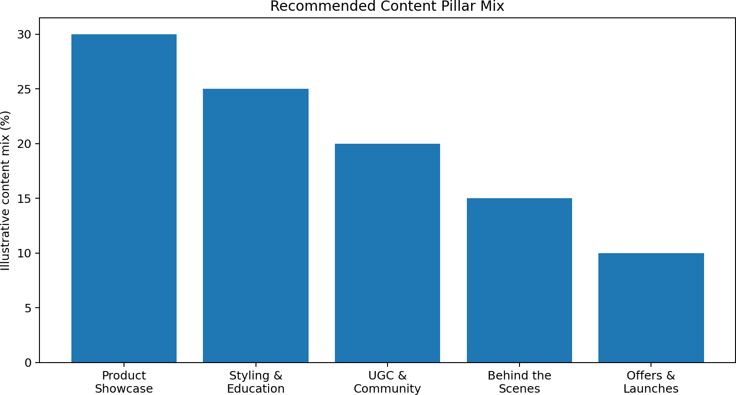

Pillar | Purpose | Examples
Product Showcase | Explain products | Details, fit, colour, features
Styling & Education | Help customers style | 3 ways, tips, occasion looks
UGC & Community | Build trust | Customer photos, reposts
Behind the Scenes | Humanize brand | Design, packing, shoot day
Offers & Launches | Support conversion | New drops, limited campaigns

Visual Consistency

A recognizable visual system helps users identify brand content quickly. Lumora should define photography direction, typography, recurring layout patterns, product presentation and video framing.

Photography Guidelines

    - Use consistent lighting direction.

    - Show full outfit and product details.

    - Include movement in selected images.
    - Use varied real-life settings.

    - Balance studio images with lifestyle visuals.
    - Show clothing from useful angles.

Video Guidelines

    - Strong first-frame visual.
    - Readable captions.

    - Fast but understandable pacing.
    - Clear product visibility.

    - Consistent opening/closing style.
    - Accessible subtitles where appropriate.

Caption Structure

A practical caption structure is: Hook → Value → Product/Story → Community prompt → Call to action.

Part | Example Purpose
Hook | Stop the scroll with a relatable style statement
Value | Give a styling tip or useful information
Story | Explain why the outfit/product matters
Prompt | Ask a relevant question
CTA | Invite the user to explore or shop

Tone of Voice

    - Friendly rather than corporate.

    - Confident without being aggressive.

    - Helpful rather than overly promotional.
    - Concise and conversational.
    - Consistent across platforms.

Purpose

Influencer and creator marketing can provide reach, social proof and relatable product demonstrations. The most appropriate creator depends on audience fit, content quality, credibility and campaign objective.

Creator Categories

Creator Type | Suggested Role
Nano creator | Local/community trust and UGC
Micro creator | Niche reach and styling content
Mid-tier creator | Broader awareness campaigns
Fashion specialist | Authority and detailed styling
Lifestyle creator | Everyday outfit integration

Selection Criteria

    - Audience relevance.

    - Engagement quality.
    - Content quality.

    - Brand-safety considerations.

    - Previous collaboration quality.
    - Ability to demonstrate products naturally.

Campaign Concept: #MyLumoraLook

Creators and customers are invited to show one Lumora piece styled in their own way. The emphasis is on individual interpretation rather than a single prescribed look.

Campaign Steps

- Identify creators whose audience matches the target segment.

- Send selected products with clear campaign information.

- Allow creators to interpret the product naturally within agreed guidelines.

- Collect approved content for brand channels.

- Invite customers to participate using the campaign hashtag.

- Measure reach, engagement, content saves, clicks and attributable sales where available.

Disclosure

Paid or gifted creator relationships should be disclosed according to applicable advertising and platform requirements. The brand should maintain transparent communication with audiences.

Why UGC Matters

User-generated content can demonstrate how products look in real situations and can provide social proof. It can also make the brand community visible to prospective customers.

UGC Collection Methods

    - Branded hashtag.
    - Post-purchase invitation.

    - Customer style feature.

    - Monthly community theme.
    - Creator-to-customer challenge.
    - Review request with content permission.

UGC Permission
The brand should request appropriate permission before republishing customer content and should respect creator/customer rights and platform rules.

UGC Content Ideas

    - How I styled it.

    - Weekend look.
    - Work-to-evening look.

    - One piece, three outfits.
    - Customer closet feature.

Role of Paid Media

Paid social can extend reach, support product launches and reconnect with people who have already interacted with the brand. Paid media should complement organic content rather than replace it.

Campaign Objectives

Objective | Creative
Awareness | Short video / creator content
Traffic | Product carousel / styling guide
Engagement | Interactive video / UGC
Conversion | Product-focused creative / offer
Retargeting | Viewed-product or engaged-user creative

Budget Principle

A practical planning model is to reserve budget across awareness, acquisition, retargeting and testing. Exact amounts should be determined from business capacity, margins, historical performance and campaign objectives.

Social-to-Commerce Journey

The ideal journey reduces friction between content discovery and product information. A user should be able to understand the product, access relevant information and reach the correct purchase page with minimal unnecessary steps.

Commerce Content

    - Shoppable product demonstrations where supported.
    - Product tags where available.

    - Creator try-ons linked to products.
    - Collection-based shopping guides.

    - Restock announcements.
    - New-arrival previews.

Conversion Support

Barrier | Social Solution
Unclear styling | Demonstration videos
Fit uncertainty | Try-on and sizing content
Lack of trust | Reviews and UGC
Choice overload | Curated edits
No urgency | Limited, truthful launch windows

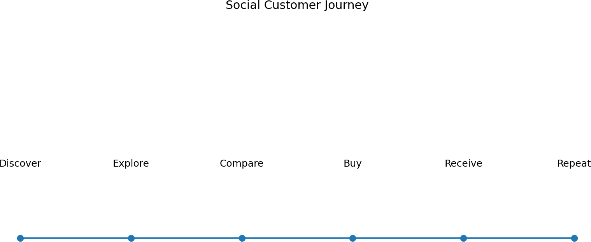

Stage | Customer Question | Brand Action
Discover | What is this brand? | Strong visual content
Explore | Will this suit me? | Styling and product education
Compare | Can I trust it? | Reviews, UGC, creator proof
Buy | How do I purchase? | Clear product CTA
Receive | Did I choose well? | Support and post-purchase content
Repeat | What should I try next? | Personalized content and launches

Engagement Tactics

    - Polls and questions.
    - This-or-that styling posts.

    - Comment prompts.
    - Live Q&A.

    - Customer reposts.

    - Creator takeovers.
    - Style challenges.
    - Story quizzes.

Community Response Framework

Situation | Response Approach
Product question | Answer clearly and link to relevant information
Positive comment | Acknowledge and continue conversation
Complaint | Respond respectfully and move detailed support to an appropriate channel
Sizing question | Provide available official sizing guidance
UGC tag | Thank user and request permission if needed

Response Principle
The goal is not to reply mechanically to every comment. Responses should add value, demonstrate care and protect brand trust.

Campaign | Concept | Main Objective
#MyLumoraLook | Customers style one piece their way | UGC / advocacy
7 Days 7 Looks | Daily outfit series | Awareness / engagement
Style Switch | One item styled for different occasions | Education
Closet Challenge | Create multiple looks from limited pieces | Engagement
Creator Edit | Creator selects favourite products | Consideration
New Drop Countdown | Pre-launch storytelling | Conversion
Behind the Label | Show design and production story | Brand connection

27.1 Campaign Selection
Campaigns should be selected based on the current business objective. Not every campaign needs to sell directly. Some should build familiarity, trust or community so that conversion campaigns have a stronger audience foundation.

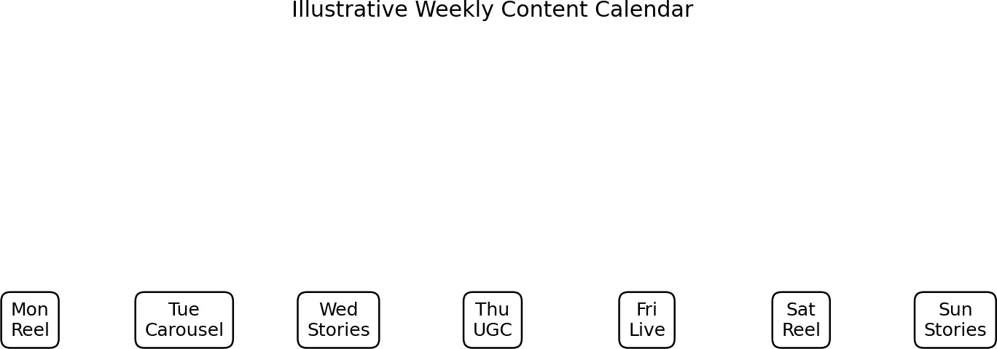

Day | Primary Content | Secondary Activity
Monday | Styling Reel | Story poll
Tuesday | Product carousel | FAQ Stories
Wednesday | Creator/UGC video | Community replies
Thursday | Educational styling post | Quiz
Friday | Launch/product content | Countdown
Saturday | Lifestyle Reel | Customer repost
Sunday | Weekly recap / inspiration | Question box

The exact posting frequency should be adjusted based on audience response, production resources and platform analytics.

Week | Theme | Key Activities
Week 1 | Brand Introduction | Brand story, hero products, founder/mission story
Week 2 | Style Education | 3-way styling, colour combinations, fit tips
Week 3 | Community | UGC, creator content, polls, customer features
Week 4 | Conversion | New drop, product proof, offer, retargeting

Content Production Workflow
Plan monthly themes. Prepare creative briefs.
Shoot product and lifestyle content. Edit platform-specific versions.
Write captions and CTAs. Schedule or publish.
Monitor comments and performance. Repurpose high-performing assets.

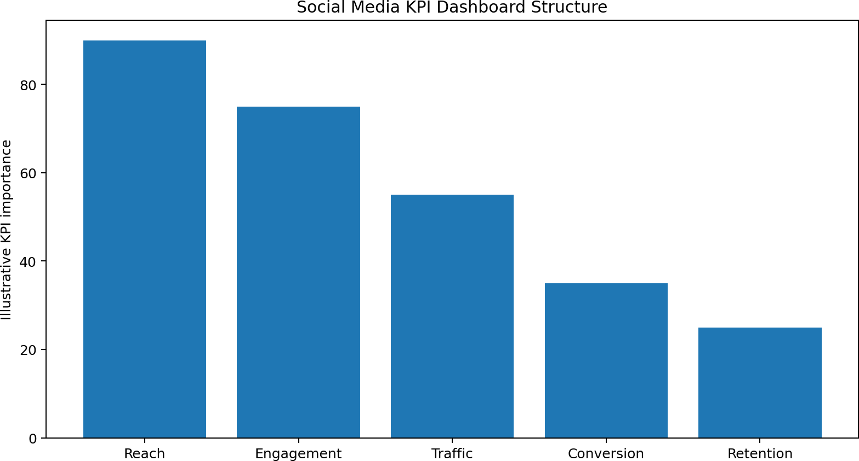

Why Measurement Matters
Measurement helps the brand understand whether social activity is producing attention, engagement, traffic, conversion and retention. Metrics should be connected to objectives rather than collected only because they are available.

Core Metrics

Objective | Metrics
Awareness | Reach, impressions, video views
Engagement | Likes, comments, shares, saves, engagement rate
Traffic | Link clicks, sessions, landing-page views
Conversion | Purchases, conversion rate, revenue where attributable
Retention | Returning users, repeat purchases, community participation

Monthly Dashboard

KPI | Baseline | Target | Actual | Action
Reach | Record | Set after baseline | Monthly value | Optimize creative
Engagement rate | Record | Set after baseline | Monthly value | Test hooks
Website sessions | Record | Set after baseline | Monthly value | Improve CTA
Conversions | Record | Set after baseline | Monthly value | Optimize landing/product journey
UGC mentions | Record | Set after baseline | Monthly value | Strengthen community campaign

Reporting Questions

    - Which content generated the most meaningful engagement?

    - Which formats generated saves or shares?
    - Which creators produced qualified traffic?

    - Which campaigns contributed to conversions?
    - Which audience segments responded best?
    - What should be stopped, continued or tested next month?

What to Test

    - Opening hook.
    - Video length.

    - Thumbnail/cover.
    - Caption length.

    - Call-to-action wording.

    - Product angle.
    - Creator vs brand presentation.
    - Offer vs education-led creative.

Testing Method
Define one variable.

Keep the audience and objective reasonably consistent. Run the test for an appropriate period.
Measure the primary KPI. Record the result.
Apply learning to the next creative cycle.

Example

Test A may begin with a product close-up while Test B begins with a styling problem. The primary KPI could be video completion or product-page clicks, depending on the campaign objective.

Potential Risks
    - Product complaints.
    - Delivery complaints.
    - Sizing dissatisfaction.
    - Negative creator feedback.
    - Misunderstood campaigns.
    - Account security incidents.
    - Viral criticism.

Crisis Response Process
Monitor the issue. Verify facts internally.
Acknowledge the concern when appropriate. Move personal/order details to private support. Provide accurate information.
Escalate serious issues to responsible teams. Document the incident and learning.

What Not to Do
    - Do not argue publicly.
    - Do not delete legitimate criticism merely because it is negative.
    - Do not invent facts.
    - Do not disclose customer personal information.
    - Do not make promises the business cannot fulfil.

Roles and Responsibilities

Role | Responsibility
Marketing Manager | Strategy, budget, approvals
Social Media Manager | Publishing, community, reporting
Content Creator | Photography/video and editing
Copywriter | Captions and campaign messaging
Designer | Visual assets
Customer Support | Customer issue resolution
Performance Marketer | Paid campaigns and optimization

Approval Workflow
Content should move from brief → creation → fact/brand check → legal/platform check where necessary → approval → scheduling → monitoring → reporting.

Brand Safety
The team should maintain access controls, two-factor authentication, approval permissions and a documented process for responding to platform or account issues.

The following is a planning framework, not a fixed financial recommendation. Actual budget should depend on business size, product margins, production costs and previous campaign performance.

Budget Area | Illustrative Share
Content production | 25%
Paid social testing | 25%
Creator partnerships | 20%
Paid conversion/retargeting | 20%
Tools and contingency | 10%

Budget Principles

    - Protect content quality.

    - Reserve money for experimentation.
    - Measure creator campaigns against clear objectives.

    - Scale campaigns only after evidence of performance.
    - Maintain contingency for seasonal opportunities.

Phase | Timeline | Key Actions
Phase 1 | Weeks 1–2 | Brand setup, audience research, platform profiles
Phase 2 | Weeks 3–4 | Content pillars, templates, first campaign
Phase 3 | Month 2 | Creator pilots, UGC, paid testing
Phase 4 | Month 3 | Scale successful formats and refine funnel
Phase 5 | Ongoing | Analytics, testing, community and content optimization

First 90 Days
The first month establishes the system. The second month focuses on learning and testing. The third month uses performance evidence to refine content, creator partnerships, paid media and conversion journeys.

Team Meeting Rhythm
    - Weekly content review.
    - Biweekly creative review.
    - Monthly performance report.
    - Quarterly strategy review.

Brand Outcomes

    - Improved brand recognition within the target audience.
    - More consistent visual and verbal identity.

    - Stronger community participation.
    - Greater volume of useful social content.

Marketing Outcomes

    - More qualified social traffic.
    - Improved content engagement.

    - More product discovery.
    - Higher quality creator content.
    - More measurable social-to-site journeys.

Business Learning

The most important outcome of a social strategy is a repeatable learning system. The brand should understand which audiences, messages, creators, formats and products generate meaningful results and then use those insights to improve future decisions.

Challenge | Recommendation
High competition | Develop distinctive content series and community identity
Trend changes | Use trends selectively and maintain evergreen pillars
Content fatigue | Repurpose strong ideas in fresh formats
Low conversion | Improve product proof and landing-page experience
Negative feedback | Use clear support and crisis response process
Creator inconsistency | Use clear briefs and creator selection criteria
Algorithm changes | Diversify platforms and build owned customer relationships

Strategic Recommendation
Lumora should treat social media as an integrated marketing system rather than a collection of posts. The strongest strategy connects content, creators, community, paid advertising, website experience and measurement.

Conclusion
A successful social media marketing strategy for a fashion brand requires more than regular posting. It requires a clear audience, strong positioning, platform-specific content, consistent visual identity, creator relationships, community participation, paid media and continuous measurement.
For the Lumora Fashion case study, the recommended strategy places visual storytelling and styling education at the centre of communication. Instagram and TikTok act as major discovery and engagement channels, while YouTube and Pinterest support deeper inspiration and search-oriented discovery. UGC and creator partnerships provide social proof, while paid media supports reach and conversion.
The strategy also emphasizes measurement. Reach, engagement, traffic, conversion and retention metrics should be connected to clear objectives. Monthly reporting and A/B testing can help the brand identify what works and improve future campaigns.
Ultimately, social media should help the fashion brand build a community around style rather than simply promote products. When useful content, authentic creators, customer stories and a smooth shopping journey work together, social media can become a sustainable part of the brand's overall marketing system.

References / Suggested Sources
    - Meta Business – official business and advertising resources.
    - TikTok for Business – official advertising and creative resources.
    - YouTube Creator resources – official creator guidance.
    - Pinterest Business – official business resources.
    - Google Analytics and Search resources for digital measurement.
    - Academic marketing textbooks and peer-reviewed research on social media marketing, consumer behaviour and fashion branding.
Note: Brand, audience figures, budgets and performance targets in this academic project are planning assumptions for the fictional Lumora Fashion case study and should be replaced with actual research data when available.

